A Project Report

on

entertainment RATING MANAGEMENT System

For AISSCE 2021 Examination

[As a part of the computer science Course (083)]

SUBMITTED BY: -

<Name>

<Roll no.>

Under the Guidance of: Mr. Amit Sethi

PGT (ComP. Sc.)

**CERTIFICATE**

This is to certify that the Project / Dissertation entitled **ENTERTAINMENT RATING MANAGEMENT SYSTEM** is a bonafide work done by ________________ of class XII Session 2020-21 in partial fulfillment of CBSE’s AISSCE Examination 2021 and has been carried out under my direct supervision and guidance. This report or a similar report on the topic has not been submitted for any other examination and does not form a part of any other course undergone by the candidate.

## ………………………………… ……………………………..

## Signature of Student Signature of Teacher/Guide

**Name: ____________ Name: Mr. Amit Sethi**

**Roll No. :___________ Design.: PGT (Comp.Sc.)**

**ACKNOWLEDGEMENT**

I

, undertook this Project work, as the part of my XII-Computer Science course(083). I had tried to apply my best of knowledge and experience, gained during the study and class work experience. However, developing software system is generally a quite complex and time-consuming process. It requires a systematic study, insight vision and professional approach during the design and development. Moreover, the developer always feels the need, the help and good wishes of the people near you, who have considerable experience and idea.

I would like to extend my sincere thanks and gratitude to my teacher

**Mr. Amit Sethi,** for giving valuable time and moral support to develop this software.

I also feel indebted to my friends for the valuable suggestions during the project work.

Name: _____________

**Class XII**

**INDEX**

1. **Introduction**------------------------------------------------------------------------------ 5
2. **Softwares and Pre-requisites**------------------------------------------------------ 6
3. **Database Design and Development**--------------------------------------------- 8
4. **Python Coding** ------------------------------------------------------------------------- 13
5. **Output**------------------------------------------------------------------------------------- 36
6. **References**------------------------------------------------------------------------------- 41

**Introduction**

This software project is developed to automate the functionalities of a **ENTERTAINMENT RATING MANAGEMENT SYSTEM.**

The name of this database is **ERDb** which stands for Entertainment Rating Database. The purpose of the software project is to develop the Management Information System (MIS) to automate the record keeping of ratings and other details of Movies, Television Shows, Games and Anime with a view to enhance the decision making of the functionaries.

This software, being simple in design and working, does not require much of training to users, and can be used as a powerful tool for automating an ENTERTAINMENT RATING DATABASE MANAGEMENT SYSTEM.

During coding and design of the software Project, Python IDLE, as a powerful front-end tool is used for getting coding simplicity. As a back-end a powerful, open source RDBMS, MySQL is used as per requirement of the CBSE curriculum of Computer Science Course (083).

**The Softwares used and Prerequisites:**

This software project is developed with the help of certain programs and some prerequisite python modules which facilitate the working of the program and make it presentable.

## The Softwares used:

* Microsoft Windows® 10 Pro as Operating System.
* Python 3.8.5 as Front-end Development environment.
* MySQL as Back-end Sever with Database for Testing.
* Mysql.Connector to connect Python module with database.
* Tabulate module to present tuples fetched from database into tables in python.
* MS-Word 2010 for documentation.

1. **Prerequisites:** I have used mysql.connector and tabulate modules in my python code. Mysql.connector module helps establishing connectivity between python and MySQL. Tabulate module helps us to present tabular data in a nicely formatted table in python. Following are the steps to install both the modules.
   1. **Steps to Install mysql.connector module:**
   * Step - 1 : Open command prompt from Start
   * Step - 2 : Enter command “python -m pip install –upgrade”
   * Step - 3 : Enter command “install mysql.connector”

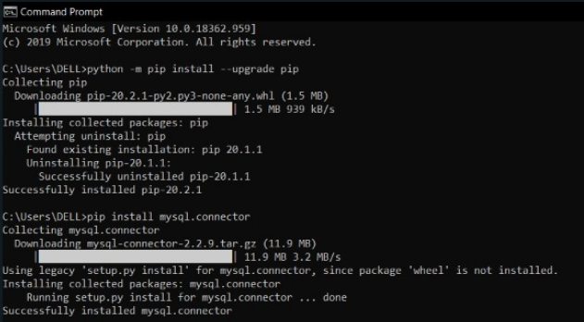

1. **Installing tabulate module**
   * Step – 1 : Open command prompt from Start.
   * Step – 2 : Enter command “pip install tabulate”.

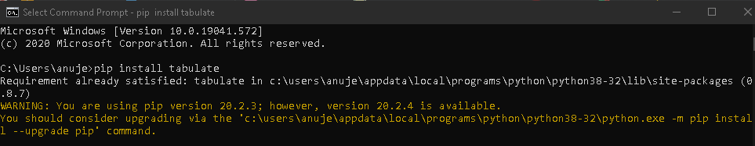

**NOTE: You must have an active internet connection while downloading the prerequisites.**

**DATABASE DESIGN AND DEVELOPMENT**

In this section I have shown the structures and records in the various tables with the queries used to create them.

Creating the Database

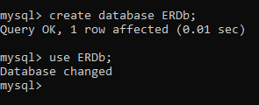

Creating table Movies

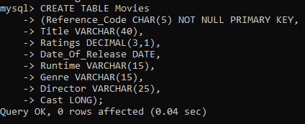

Structure of Movies

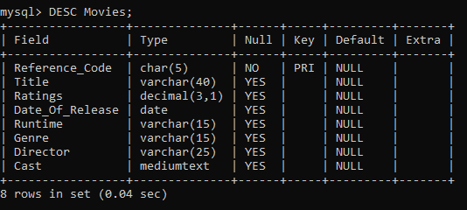

Inserting Records into Movies Table

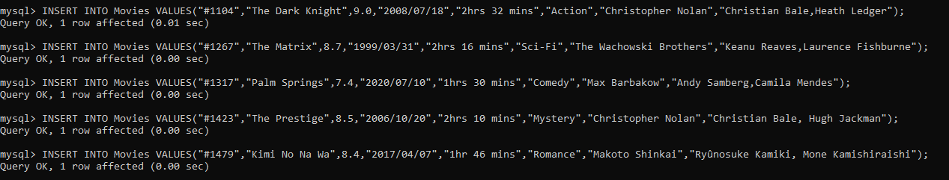

All Records in Movies Table

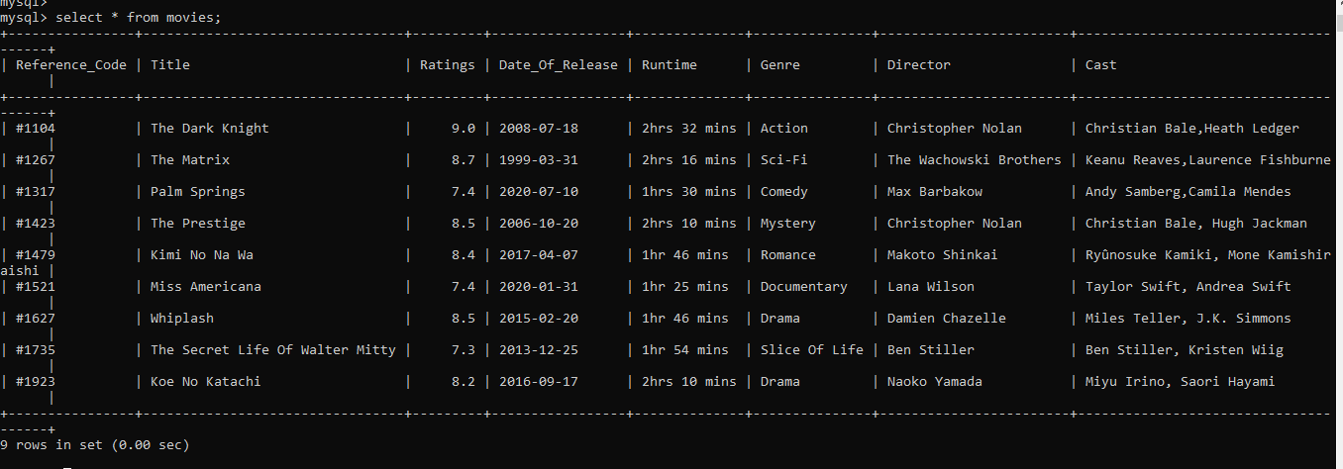

Creating Table Tv_Shows

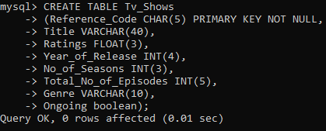

Structure Of Tv_Shows Table

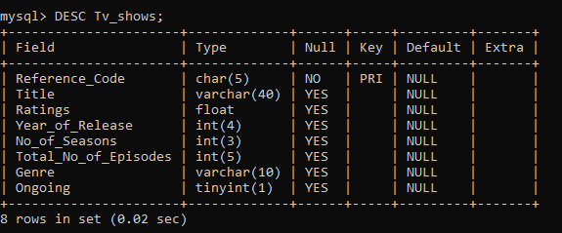

Inserting Records into Tv_Shows Table

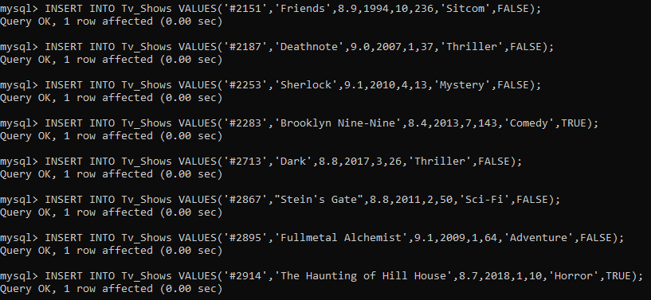

All Records in Tv_Shows Table

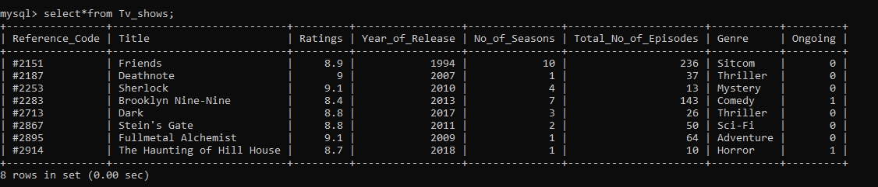

Creating Table Video_Games

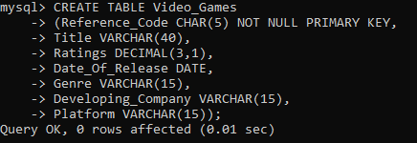

Structure Of Video_Games Table

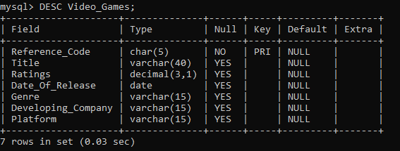

Inserting Records into The Video_Games Table

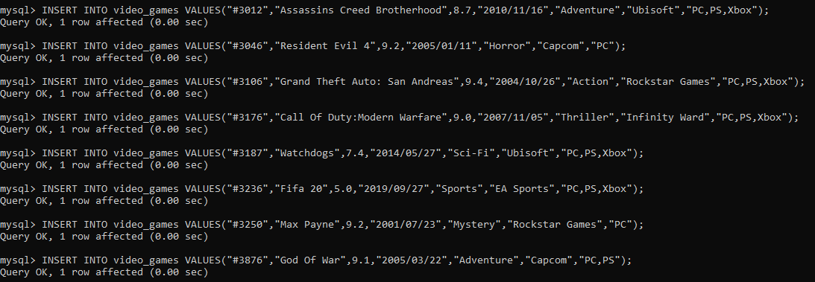

All records in the Video_Games Table

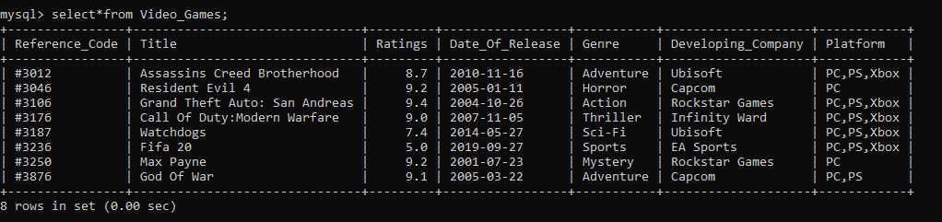

Creating Table Anime

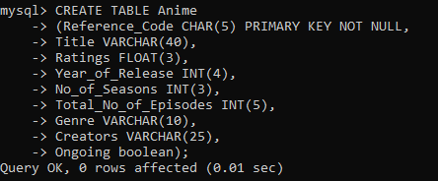

Structure Of Anime Table

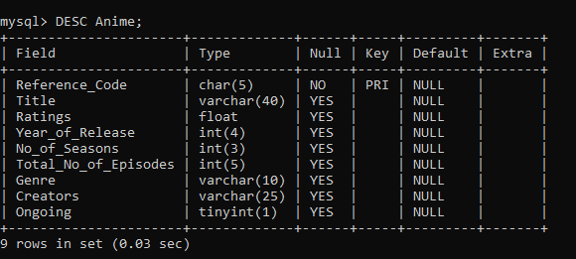

Inserting Records in the Anime Table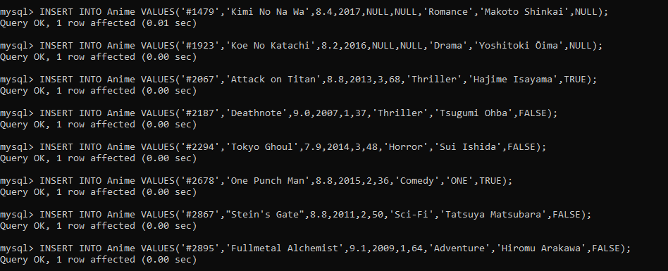

All Records in Anime Table

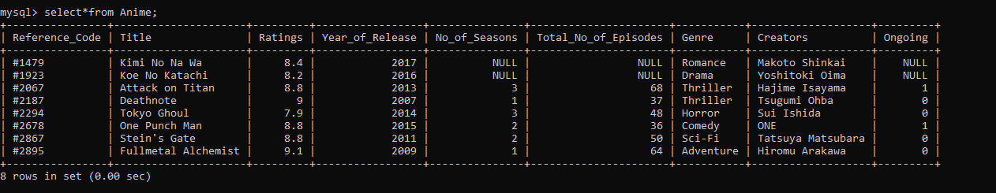

**Python Coding**

1. **from** tabulate **import** tabulate
2. **print**("Welcome to ERDb database")
3. **def** main_menu():
4. **print**("The  following operations can be done on this database.")
5. **print**("1.Display table data")
6. **print**("2.Update any table")
7. **print**("3.Search any table")
8. **print**("4.Insert new record")
9. **print**("5.Delete any record")
10. **print**("6.Display Anime movies")
11. **print**("7.Display Anime shows")
12. **print**("8.Exit")
13. r=int(input("Enter number corresponding to ymy choice: "))
14. **if** r==1:
15. Display()
16. **elif** r==2:
17. Update()
18. **elif** r==3:
19. Search()
20. **elif** r==4:
21. Insert()
22. **elif** r==5:
23. Delete()
24. **elif** r==6:
25. DisplayAmovie()
26. **elif** r==7:
27. DisplayAshow()
28. **elif** r==8:
29. exit()
30. **else**:
31. **print**("Enter appropriate number!!!")
32. main_menu()
34. **def** Display():
35. **import** mysql.connector
36. mydb=mysql.connector.connect(host="localhost",user="root",passwd="agnel",database="ERDb")
37. mycursor=mydb.cursor()
38. **print**("Welcome to Display Menu!")
39. **print**("Select one of the below tables")
40. **print**("1. Movies")
41. **print**("2. Tv Shows")
42. **print**("3. Video Games")
43. **print**("4. Anime")
44. **print**("5.Go back to main menu")
45. userInput=int(input("Please Select An Above Option: "))
46. **if**(userInput == 1):
47. **print**("Display:")
48. **print**("1. All Details")
49. **print**("2. Details sorted by Increasing order of Ratings")
50. **print**("3. Details sorted by Decreasing order of Ratings")
51. **print**("4. Details sorted by Increasing order of Date of Release")
52. **print**("5. Details sorted by Decreasing order of Date of Release")
53. **print**("6. Go back to Main Menu")
54. x1=int(input("Enter any one of the above choices: "))
55. **if** x1==1:
56. sql="select * from Movies;"
57. mycursor.execute(sql)
58. res=mycursor.fetchall()
59. t=tabulate(res, headers=['Reference_Code','Title','Ratings','Date_Of_Release','Runtime','Genre','Director','Cast'])
60. **print**(t)
61. b=int(input("Enter 1 if you want to go back to the Display Menu, 2 if you want to go back to the Main Menu or any other number to Exit the program: "))
62. **if** b==1:
63. Display()
64. **elif** b==2:
65. main_menu()
66. **else**:
67. **print**("THANK YOU FOR USING ERDb!! :)")
68. exit()
70. **elif** x1==2:
71. sql="select * from Movies order by Ratings;"
72. mycursor.execute(sql)
73. res=mycursor.fetchall()
74. t=tabulate(res, headers=['Reference_Code','Title','Ratings','Date_Of_Release','Runtime','Genre','Director','Cast'])
75. **print**(t)
76. b=int(input("Enter 1 if you want to go back to the Display Menu, 2 if you want to go back to the Main Menu or any other number to Exit the program: "))
77. **if** b==1:
78. Display()
79. **elif** b==2:
80. main_menu()
81. **else**:
82. **print**("THANK YOU FOR USING ERDb!! :)")
83. exit()
85. **elif** x1==3:
86. sql="select * from Movies order by Ratings desc;"
87. mycursor.execute(sql)
88. res=mycursor.fetchall()
89. t=tabulate(res, headers=['Reference_Code','Title','Ratings','Date_Of_Release','Runtime','Genre','Director','Cast'])
90. **print**(t)
91. b=int(input("Enter 1 if you want to go back to the Display Menu, 2 if you want to go back to the Main Menu or any other number to Exit the program: "))
92. **if** b==1:
93. Display()
94. **elif** b==2:
95. main_menu()
96. **else**:
97. **print**("THANK YOU FOR USING ERDb!! :)")
98. exit()
100. **elif** x1==4:
101. sql="select * from Movies order by Date_Of_Release;"
102. mycursor.execute(sql)
103. res=mycursor.fetchall()
104. t=tabulate(res, headers=['Reference_Code','Title','Ratings','Date_Of_Release','Runtime','Genre','Director','Cast'])
105. **print**(t)
106. b=int(input("Enter 1 if you want to go back to the Display Menu, 2 if you want to go back to the Main Menu or any other number to Exit the program: "))
107. **if** b==1:
108. Display()
109. **elif** b==2:
110. main_menu()
111. **else**:
112. **print**("THANK YOU FOR USING ERDb!! :)")
113. exit()
115. **elif** x1==5:
116. sql="select * from Movies order by Date_Of_Release desc;"
117. mycursor.execute(sql)
118. res=mycursor.fetchall()
119. t=tabulate(res, headers=['Reference_Code','Title','Ratings','Date_Of_Release','Runtime','Genre','Director','Cast'])
120. **print**(t)
121. b=int(input("Enter 1 if you want to go back to the Display Menu, 2 if you want to go back to the Main Menu or any other number to Exit the program: "))
122. **if** b==1:
123. Display()
124. **elif** b==2:
125. main_menu()
126. **else**:
127. **print**("THANK YOU FOR USING ERDb!! :)")
128. exit()
129. **elif** x1==6:
130. main_menu()
132. **else**:
133. **print**("Enter an appropriate number")
134. Display()
135. **elif**(userInput == 2):
136. **print**("Display:")
137. **print**("1. All Details")
138. **print**("2. Details sorted by Increasing order of Ratings")
139. **print**("3. Details sorted by Decreasing order of Ratings")
140. **print**("4. Details sorted by Increasing order of Date of Release")
141. **print**("5. Details sorted by Decreasing order of Date of Release")
142. **print**("6. Details sorted by Increasing order of Number of Seasons")
143. **print**("7. Details sorted by Decreasing order of Number of Seasons")
144. **print**("8. Details sorted by Increasing order of Number of Episodes")
145. **print**("9. Details sorted by Decreasing order of Number of Episodes")
146. **print**("10. Go back to Main Menu")
147. x1=int(input("Enter any one of the above choices: "))
148. **if** x1==1:
149. sql="select * from Tv_Shows;"
150. mycursor.execute(sql)
151. res=mycursor.fetchall()
152. t=tabulate(res, headers=['Reference_Code','Title','Ratings','Year_Of_Release','No_of_Seasons','Total_No_of_Episodes','Genre','Ongoing'])
153. **print**(t)
154. b=int(input("Enter 1 if you want to go back to the Display Menu, 2 if you want to go back to the Main Menu or any other number to Exit the program: "))
155. **if** b==1:
156. Display()
157. **elif** b==2:
158. main_menu()
159. **else**:
160. **print**("THANK YOU FOR USING ERDb!! :)")
161. exit()
162. **elif** x1==2:
163. sql="select * from Tv_Shows order by Ratings;"
164. mycursor.execute(sql)
165. res=mycursor.fetchall()
166. t=tabulate(res, headers=['Reference_Code','Title','Ratings','Year_Of_Release','No_of_Seasons','Total_No_of_Episodes','Genre','Ongoing'])
167. **print**(t)
168. b=int(input("Enter 1 if you want to go back to the Display Menu, 2 if you want to go back to the Main Menu or any other number to Exit the program: "))
169. **if** b==1:
170. Display()
171. **elif** b==2:
172. main_menu()
173. **else**:
174. **print**("THANK YOU FOR USING ERDb!! :)")
175. exit()
177. **elif** x1==3:
178. sql="select * from Tv_Shows order by Ratings desc;"
179. mycursor.execute(sql)
180. res=mycursor.fetchall()
181. t=tabulate(res, headers=['Reference_Code','Title','Ratings','Year_Of_Release','No_of_Seasons','Total_No_of_Episodes','Genre','Ongoing'])
182. **print**(t)
183. b=int(input("Enter 1 if you want to go back to the Display Menu, 2 if you want to go back to the Main Menu or any other number to Exit the program: "))
184. **if** b==1:
185. Display()
186. **elif** b==2:
187. main_menu()
188. **else**:
189. **print**("THANK YOU FOR USING ERDb!! :)")
190. exit()
192. **elif** x1==4:
193. sql="select * from Tv_Shows order by Year_Of_Release;"
194. mycursor.execute(sql)
195. res=mycursor.fetchall()
196. t=tabulate(res, headers=['Reference_Code','Title','Ratings','Year_Of_Release','No_of_Seasons','Total_No_of_Episodes','Genre','Ongoing'])
197. **print**(t)
198. b=int(input("Enter 1 if you want to go back to the Display Menu, 2 if you want to go back to the Main Menu or any other number to Exit the program: "))
199. **if** b==1:
200. Display()
201. **elif** b==2:
202. main_menu()
203. **else**:
204. **print**("THANK YOU FOR USING ERDb!! :)")
205. exit()
207. **elif** x1==5:
208. sql="select * from Tv_Shows order by Year_Of_Release desc;"
209. mycursor.execute(sql)
210. res=mycursor.fetchall()
211. t=tabulate(res, headers=['Reference_Code','Title','Ratings','Year_Of_Release','No_of_Seasons','Total_No_of_Episodes','Genre','Ongoing'])
212. **print**(t)
213. b=int(input("Enter 1 if you want to go back to the Display Menu, 2 if you want to go back to the Main Menu or any other number to Exit the program: "))
214. **if** b==1:
215. Display()
216. **elif** b==2:
217. main_menu()
218. **else**:
219. **print**("THANK YOU FOR USING ERDb!! :)")
220. exit()
221. **elif** x1==6:
222. sql="select * from Tv_Shows order by No_of_Seasons;"
223. mycursor.execute(sql)
224. res=mycursor.fetchall()
225. t=tabulate(res, headers=['Reference_Code','Title','Ratings','Year_Of_Release','No_of_Seasons','Total_No_of_Episodes','Genre','Ongoing'])
226. **print**(t)
227. b=int(input("Enter 1 if you want to go back to the Display Menu, 2 if you want to go back to the Main Menu or any other number to Exit the program: "))
228. **if** b==1:
229. Display()
230. **elif** b==2:
231. main_menu()
232. **else**:
233. **print**("THANK YOU FOR USING ERDb!! :)")
234. exit()
235. **elif** x1==7:
236. sql="select * from Tv_Shows order by No_of_Seasons desc;"
237. mycursor.execute(sql)
238. res=mycursor.fetchall()
239. t=tabulate(res, headers=['Reference_Code','Title','Ratings','Year_Of_Release','No_of_Seasons','Total_No_of_Episodes','Genre','Ongoing'])
240. **print**(t)
241. b=int(input("Enter 1 if you want to go back to the Display Menu, 2 if you want to go back to the Main Menu or any other number to Exit the program: "))
242. **if** b==1:
243. Display()
244. **elif** b==2:
245. main_menu()
246. **else**:
247. **print**("THANK YOU FOR USING ERDb!! :)")
248. exit()
249. **elif** x1==8:
250. sql="select * from Tv_Shows order by Total_No_of_Episodes;"
251. mycursor.execute(sql)
252. res=mycursor.fetchall()
253. t=tabulate(res, headers=['Reference_Code','Title','Ratings','Year_Of_Release','No_of_Seasons','Total_No_of_Episodes','Genre','Ongoing'])
254. **print**(t)
255. b=int(input("Enter 1 if you want to go back to the Display Menu, 2 if you want to go back to the Main Menu or any other number to Exit the program: "))
256. **if** b==1:
257. Display()
258. **elif** b==2:
259. main_menu()
260. **else**:
261. **print**("THANK YOU FOR USING ERDb!! :)")
262. exit()
263. **elif** x1==9:
264. b=int(input("Enter 1 if you want to go back to the Display Menu, 2 if you want to go back to the Main Menu or any other number to Exit the program: "))
265. **if** b==1:
266. Display()
267. **elif** b==2:
268. main_menu()
269. **else**:
270. **print**("THANK YOU FOR USING ERDb!! :)")
271. exit()
272. **elif** x1==10:
273. main_menu()
275. **else**:
276. **print**("Enter an appropriate number")
277. Display()
279. **elif**(userInput == 3):
280. **print**("Display:")
281. **print**("1. All Details")
282. **print**("2. Details sorted by Increasing order of Ratings")
283. **print**("3. Details sorted by Decreasing order of Ratings")
284. **print**("4. Details sorted by Increasing order of Date of Release")
285. **print**("5. Details sorted by Decreasing order of Date of Release")
286. **print**("6. Go back to Main Menu")
287. x1=int(input("Enter any one of the above choices: "))
288. **if** x1==1:
289. sql="select * from video_games;"
290. mycursor.execute(sql)
291. res=mycursor.fetchall()
292. t=tabulate(res, headers=['Reference_Code','Title','Ratings','Date_Of_Release','Genre','Developing_Company','Platforms'])
293. **print**(t)
294. b=int(input("Enter 1 if you want to go back to the Display Menu, 2 if you want to go back to the Main Menu or any other number to Exit the program: "))
295. **if** b==1:
296. Display()
297. **elif** b==2:
298. main_menu()
299. **else**:
300. **print**("THANK YOU FOR USING ERDb!! :)")
301. exit()
303. **elif** x1==2:
304. sql="select * from video_games order by Ratings;"
305. mycursor.execute(sql)
306. res=mycursor.fetchall()
307. t=tabulate(res, headers=['Reference_Code','Title','Ratings','Date_Of_Release','Genre','Developing_Company','Platforms'])
308. **print**(t)
309. b=int(input("Enter 1 if you want to go back to the Display Menu, 2 if you want to go back to the Main Menu or any other number to Exit the program: "))
310. **if** b==1:
311. Display()
312. **elif** b==2:
313. main_menu()
314. **else**:
315. **print**("THANK YOU FOR USING ERDb!! :)")
316. exit()
318. **elif** x1==3:
319. sql="select * from video_games order by Ratings desc;"
320. mycursor.execute(sql)
321. res=mycursor.fetchall()
322. t=tabulate(res, headers=['Reference_Code','Title','Ratings','Date_Of_Release','Genre','Developing_Company','Platforms'])
323. **print**(t)
324. b=int(input("Enter 1 if you want to go back to the Display Menu, 2 if you want to go back to the Main Menu or any other number to Exit the program: "))
325. **if** b==1:
326. Display()
327. **elif** b==2:
328. main_menu()
329. **else**:
330. **print**("THANK YOU FOR USING ERDb!! :)")
331. exit()
333. **elif** x1==4:
334. sql="select * from video_games order by Date_Of_Release;"
335. mycursor.execute(sql)
336. res=mycursor.fetchall()
337. t=tabulate(res, headers=['Reference_Code','Title','Ratings','Date_Of_Release','Genre','Developing_Company','Platforms'])
338. **print**(t)
339. b=int(input("Enter 1 if you want to go back to the Display Menu, 2 if you want to go back to the Main Menu or any other number to Exit the program: "))
340. **if** b==1:
341. Display()
342. **elif** b==2:
343. main_menu()
344. **else**:
345. **print**("THANK YOU FOR USING ERDb!! :)")
346. exit()
348. **elif** x1==5:
349. sql="select * from video_games order by Date_Of_Release desc;"
350. mycursor.execute(sql)
351. res=mycursor.fetchall()
352. t=tabulate(res, headers=['Reference_Code','Title','Ratings','Date_Of_Release','Genre','Developing_Company','Platforms'])
353. **print**(t)
354. b=int(input("Enter 1 if you want to go back to the Display Menu, 2 if you want to go back to the Main Menu or any other number to Exit the program: "))
355. **if** b==1:
356. Display()
357. **elif** b==2:
358. main_menu()
359. **else**:
360. **print**("THANK YOU FOR USING ERDb!! :)")
361. exit()
362. **elif** x1==6:
363. main_menu()
365. **else**:
366. **print**("Enter an appropriate number")
367. Display()
368. **elif**(userInput == 4):
369. **print**("Display:")
370. **print**("1. All Details")
371. **print**("2. Details sorted by Increasing order of Ratings")
372. **print**("3. Details sorted by Decreasing order of Ratings")
373. **print**("4. Details sorted by Increasing order of Date of Release")
374. **print**("5. Details sorted by Decreasing order of Date of Release")
375. **print**("6. Details sorted by Increasing order of Number of Seasons")
376. **print**("7. Details sorted by Decreasing order of Number of Seasons")
377. **print**("8. Details sorted by Increasing order of Number of Episodes")
378. **print**("9. Details sorted by Decreasing order of Number of Episodes")
379. **print**("10. Go back to Main Menu")
380. x1=int(input("Enter any one of the above choices: "))
381. **if** x1==1:
382. sql="select * from Anime;"
383. mycursor.execute(sql)
384. res=mycursor.fetchall()
385. t=tabulate(res, headers=['Reference_Code','Title','Ratings','Year_of_Release','No_of_Seasons','Total_No_of_Episodes','Genre','Creators','Ongoing'])
386. **print**(t)
387. b=int(input("Enter 1 if you want to go back to the Display Menu, 2 if you want to go back to the Main Menu or any other number to Exit the program: "))
388. **if** b==1:
389. Display()
390. **elif** b==2:
391. main_menu()
392. **else**:
393. **print**("THANK YOU FOR USING ERDb!! :)")
394. exit()
395. **elif** x1==2:
396. sql="select * from Anime order by Ratings;"
397. mycursor.execute(sql)
398. res=mycursor.fetchall()
399. t=tabulate(res, headers=['Reference_Code','Title','Ratings','Year_of_Release','No_of_Seasons','Total_No_of_Episodes','Genre','Creators','Ongoing'])
400. **print**(t)
401. b=int(input("Enter 1 if you want to go back to the Display Menu, 2 if you want to go back to the Main Menu or any other number to Exit the program: "))
402. **if** b==1:
403. Display()
404. **elif** b==2:
405. main_menu()
406. **else**:
407. **print**("THANK YOU FOR USING ERDb!! :)")
408. exit()
410. **elif** x1==3:
411. sql="select * from Anime order by Ratings desc;"
412. mycursor.execute(sql)
413. res=mycursor.fetchall()
414. t=tabulate(res, headers=['Reference_Code','Title','Ratings','Year_of_Release','No_of_Seasons','Total_No_of_Episodes','Genre','Creators','Ongoing'])
415. **print**(t)
416. b=int(input("Enter 1 if you want to go back to the Display Menu, 2 if you want to go back to the Main Menu or any other number to Exit the program: "))
417. **if** b==1:
418. Display()
419. **elif** b==2:
420. main_menu()
421. **else**:
422. **print**("THANK YOU FOR USING ERDb!! :)")
423. exit()
425. **elif** x1==4:
426. sql="select * from Anime order by Year_Of_Release;"
427. mycursor.execute(sql)
428. res=mycursor.fetchall()
429. t=tabulate(res, headers=['Reference_Code','Title','Ratings','Year_of_Release','No_of_Seasons','Total_No_of_Episodes ','Genre','Creators','Ongoing'])
430. **print**(t)
431. b=int(input("Enter 1 if you want to go back to the Display Menu, 2 if you want to go back to the Main Menu or any other number to Exit the program: "))
432. **if** b==1:
433. Display()
434. **elif** b==2:
435. main_menu()
436. **else**:
437. **print**("THANK YOU FOR USING ERDb!! :)")
438. exit()
440. **elif** x1==5:
441. sql="select * from Anime order by Year_Of_Release desc;"
442. mycursor.execute(sql)
443. res=mycursor.fetchall()
444. t=tabulate(res, headers=['Reference_Code','Title','Ratings','Year_of_Release','No_of_Seasons','Total_No_of_Episodes','Genre','Creators','Ongoing'])
445. **print**(t)
446. b=int(input("Enter 1 if you want to go back to the Display Menu, 2 if you want to go back to the Main Menu or any other number to Exit the program: "))
447. **if** b==1:
448. Display()
449. **elif** b==2:
450. main_menu()
451. **else**:
452. **print**("THANK YOU FOR USING ERDb!! :)")
453. exit()
454. **elif** x1==6:
455. sql="select * from Anime order by No_of_Seasons;"
456. mycursor.execute(sql)
457. res=mycursor.fetchall()
458. t=tabulate(res, headers=['Reference_Code','Title','Ratings','Year_of_Release','No_of_Seasons','Total_No_of_Episodes','Genre','Creators','Ongoing'])
459. **print**(t)
460. b=int(input("Enter 1 if you want to go back to the Display Menu, 2 if you want to go back to the Main Menu or any other number to Exit the program: "))
461. **if** b==1:
462. Display()
463. **elif** b==2:
464. main_menu()
465. **else**:
466. **print**("THANK YOU FOR USING ERDb!! :)")
467. exit()
468. **elif** x1==7:
469. sql="select * from Anime order by No_of_Seasons desc;"
470. mycursor.execute(sql)
471. res=mycursor.fetchall()
472. t=tabulate(res, headers=['Reference_Code','Title','Ratings','Year_of_Release','No_of_Seasons','Total_No_of_Episodes','Genre','Creators','Ongoing'])
473. **print**(t)
474. b=int(input("Enter 1 if you want to go back to the Display Menu, 2 if you want to go back to the Main Menu or any other number to Exit the program: "))
475. **if** b==1:
476. Display()
477. **elif** b==2:
478. main_menu()
479. **else**:
480. **print**("THANK YOU FOR USING ERDb!! :)")
481. exit()
482. **elif** x1==8:
483. sql="select * from Anime order by Total_No_of_Episodes;"
484. mycursor.execute(sql)
485. res=mycursor.fetchall()
486. t=tabulate(res, headers=['Reference_Code','Title','Ratings','Year_of_Release','No_of_Seasons','Total_No_of_Episodes','Genre','Creators','Ongoing'])
487. **print**(t)
488. b=int(input("Enter 1 if you want to go back to the Display Menu, 2 if you want to go back to the Main Menu or any other number to Exit the program: "))
489. **if** b==1:
490. Display()
491. **elif** b==2:
492. main_menu()
493. **else**:
494. **print**("THANK YOU FOR USING ERDb!! :)")
495. exit()
496. **elif** x1==9:
497. sql="select * from Anime order by Total_No_of_Episodes desc;"
498. mycursor.execute(sql)
499. res=mycursor.fetchall()
500. t=tabulate(res, headers=['Reference_Code','Title','Ratings','Year_of_Release','No_of_Seasons','Total_No_of_Episodes','Genre','Creators','Ongoing'])
501. **print**(t)
502. b=int(input("Enter 1 if you want to go back to the Display Menu, 2 if you want to go back to the Main Menu or any other number to Exit the program: "))
503. **if** b==1:
504. Display()
505. **elif** b==2:
506. main_menu()
507. **else**:
508. **print**("THANK YOU FOR USING ERDb!! :)")
509. exit()
510. **elif** x1==10:
511. main_menu()
513. **else**:
514. **print**("Enter an appropriate number")
515. Display()
516. **elif**(userInput==5):
517. main_menu()

520. **def** Update():
521. **print**("Welcome to Update Menu!")
522. **print**("1. Update Movies")
523. **print**("2. Update Tv Shows")
524. **print**("3. Update Video Games")
525. **print**("4. Update Anime")
526. **print**("5. Go back to Main menu")
527. n1=int(input("Enter any one of the above choices: "))
528. **if** n1==1:
529. UpdateMovie()
530. **elif** n1==2:
531. UpdateTvshow()
532. **elif** n1==3:
533. UpdateVideoGames()
534. **elif** n1==4:
535. UpdateAnime()
536. **elif** n1==5:
537. main_menu()
539. **def** UpdateMovie():
540. **import** mysql.connector
541. mycon=mysql.connector.connect(host="localhost",user="root",passwd="agnel",database="ERDb")
542. mycursor=mycon.cursor()
543. Ref_code=str(input("Enter a 4 digit reference code (Include it in quoutes \" \"): "))
544. fld=input("Enter the field which you want to edit : ")
545. **print**("Select one of the options")
546. **print**("1. Update an existing value to new value")
547. **print**("2. Update an existing vlaue to a NULL value")
548. n2=int(input("Enter a choice : "))
549. **if** n2==1:
550. newval=input("Enter the value you want to set(Include it in quoutes \" \") : ")
551. sql="Update Movies set " + fld +"=" + newval + " where Reference_Code=" + Ref_code + ";"
552. mycursor.execute(sql)
553. **if** mycursor.rowcount==0:
554. **print**("No Such Record Found")
555. **else**:
556. **print**("Editing Done: ")
557. **print**("After correction the record is : ")
558. sql="select * from Movies where Reference_Code=" + Ref_code + ";"
559. mycursor.execute(sql)
560. res=mycursor.fetchall()
561. t=tabulate(res, headers=['Reference_Code','Title','Ratings','Date_Of_Release','Runtime','Genre','Director','Cast'])
562. **print**(t)
563. mycon.commit()
565. **elif** n2==2:
566. sql="Update Movies set " + fld +"= NULL where Reference_Code=" + Ref_code + ";"
567. mycursor.execute(sql)
568. **if** mycursor.rowcount==0:
569. **print**("No Such Record Found")
570. **else**:
571. **print**("Editing Done!")
572. **print**("After correction the record is : ")
573. sql="select * from Movies where Reference_Code=" + Ref_code + ";"
574. mycursor.execute(sql)
575. res=mycursor.fetchall()
576. t=tabulate(res, headers=['Reference_Code','Title','Ratings','Date_Of_Release','Runtime','Genre','Director','Cast'])
577. **print**(t)
578. mycon.commit()
579. h=int(input("Enter 1 if you want to Update more Records in the same table, 2 if you want to go to the Update Menu to select some other table, 3 if you want to go back to the Main Menu and any other number to Exit the program: "))
580. **if** h==1:
581. UpdateMovie()
582. **elif** h==2:
583. Update()
584. **elif** h==3:
585. main_menu()
586. **else**:
587. **print**("THANK YOU FOR USING ERDb!! :)")
588. exit()
590. **def** UpdateTvshow():
591. **import** mysql.connector
592. mycon=mysql.connector.connect(host="localhost",user="root",passwd="agnel",database="ERDb")
593. mycursor=mycon.cursor()
594. Ref_code=str(input("Enter a 4 digit reference code (Include it in quoutes \" \"): "))
595. fld=input("Enter the field which you want to edit : ")
596. **print**("Select one of the options")
597. **print**("1. Update an existing value to new value")
598. **print**("2. Update an existing vlaue to a NULL value")
599. n2=int(input("Enter a choice : "))
600. **if** n2==1:
601. newval=input("Enter the value you want to set (Include it in quoutes \" \"): ")
602. sql="Update Tv_Shows set " + fld +"=" + newval + " where Reference_Code=" + Ref_code + ";"
603. mycursor.execute(sql)
604. **if** mycursor.rowcount==0:
605. **print**("No Such Record Found")
606. **else**:
607. **print**("Editing Done: ")
608. **print**("After correction the record is : ")
609. sql="select * from Tv_Shows where Reference_Code=" + Ref_code + ";"
610. mycursor.execute(sql)
611. res=mycursor.fetchall()
612. t=tabulate(res, headers=['Reference_Code','Title','Ratings','Year_Of_Release','No_of_Seasons','Total_No_of_Episodes','Genre'])
613. **print**(t)
614. mycon.commit()
615. **elif** n2==2:
616. sql="Update Tv_Shows set " + fld +"= NULL where Reference_Code=" + Ref_code + ";"
617. mycursor.execute(sql)
618. **if** mycursor.rowcount==0:
619. **print**("No Such Record Found")
620. **else**:
621. **print**("Editing Done: ")
622. **print**("After correction the record is : ")
623. sql="select * from Tv_Shows where Reference_Code=" + Ref_code + ";"
624. mycursor.execute(sql)
625. res=mycursor.fetchall()
626. t=tabulate(res, headers=['Reference_Code','Title','Ratings','Year_Of_Release','No_of_Seasons','Total_No_of_Episodes','Genre'])
627. **print**(t)
628. mycon.commit()
629. h=int(input("Enter 1 if you want to Update more Records in the same table, 2 if you want to go to the Update Menu to select some other table, 3 if you want to go back to the Main Menu and any other number to Exit the program: "))
630. **if** h==1:
631. UpdateTvshow()
632. **elif** h==2:
633. Update()
634. **elif** h==3:
635. main_menu()
636. **else**:
637. **print**("THANK YOU FOR USING ERDb!! :)")
638. exit()
640. **def** UpdateVideoGames():
641. **import** mysql.connector
642. mycon=mysql.connector.connect(host="localhost",user="root",passwd="agnel",database="ERDb")
643. mycursor=mycon.cursor()
644. Ref_code=str(input("Enter a 4 digit reference code (Include it in quoutes \" \"): "))
645. fld=input("Enter the field which you want to edit : ")
646. **print**("Select one of the options")
647. **print**("1. Update an existing value to new value")
648. **print**("2. Update an existing vlaue to a NULL value")
649. n2=int(input("Enter a choice : "))
650. **if** n2==1:
651. newval=input("Enter the value you want to set (Include it in quoutes \" \"): ")
652. sql="Update Video_Games set " + fld +"=" + newval + " where Reference_Code=" + Ref_code + ";"
653. mycursor.execute(sql)
654. **if** mycursor.rowcount==0:
655. **print**("No Such Record Found")
656. **else**:
657. **print**("Editing Done: ")
658. **print**("After correction the record is : ")
659. sql="select * from Video_Games where Reference_Code=" + Ref_code + ";"
660. mycursor.execute(sql)
661. res=mycursor.fetchall()
662. t=tabulate(res, headers=['Reference_Code','Title','Ratings','Date_Of_Release','Genre','Developing_Company','Platforms'])
663. **print**(t)
664. mycon.commit()
665. **elif** n2==2:
666. sql="Update Video_Games set " + fld +"= NULL where Reference_Code=" + Ref_code + ";"
667. mycursor.execute(sql)
668. **if** mycursor.rowcount==0:
669. **print**("No Such Record Found")
670. **else**:
671. **print**("Editing Done: ")
672. **print**("After correction the record is : ")
673. sql="select * from Video_Games where Reference_Code=" + Ref_code + ";"
674. mycursor.execute(sql)
675. res=mycursor.fetchall()
676. t=tabulate(res, headers=['Reference_Code','Title','Ratings','Date_Of_Release','Genre','Developing_Company','Platforms'])
677. **print**(t)
678. mycon.commit()
679. h=int(input("Enter 1 if you want to Update more Records in the same table, 2 if you want to go to the Update Menu to select some other table, 3 if you want to go back to the Main Menu and any other number to Exit the program: "))
680. **if** h==1:
681. UpdateVideoGames()
682. **elif** h==2:
683. Update()
684. **elif** h==3:
685. main_menu()
686. **else**:
687. **print**("THANK YOU FOR USING ERDb!! :)")
688. exit()
690. **def** UpdateAnime():
691. **import** mysql.connector
692. mycon=mysql.connector.connect(host="localhost",user="root",passwd="agnel",database="ERDb")
693. mycursor=mycon.cursor()
694. Ref_code=str(input("Enter a 4 digit reference code (Include it in quoutes \" \"): "))
695. fld=input("Enter the field which you want to edit : ")
696. **print**("Select one of the options")
697. **print**("1. Update an existing value to new value")
698. **print**("2. Update an existing vlaue to a NULL value")
699. n2=int(input("Enter a choice : "))
700. **if** n2==1:
701. newval=input("Enter the value you want to set (Include it in quoutes \" \"): ")
702. sql="Update Anime set " + fld +"=" + newval + " where Reference_Code=" + Ref_code + ";"
703. mycursor.execute(sql)
704. **if** mycursor.rowcount==0:
705. **print**("No Such Record Found")
706. **else**:
707. **print**("Editing Done: ")
708. **print**("After correction the record is : ")
709. sql="select * from Anime where Reference_Code=" + Ref_code + ";"
710. mycursor.execute(sql)
711. res=mycursor.fetchall()
712. t=tabulate(res, headers=['Reference_Code','Title','Ratings','Year_of_Release','No_of_Seasons','Total_No_of_Episodes','Genre','Creators'])
713. **print**(t)
714. mycon.commit()
715. **elif** n2==2:
716. sql="Update Anime set " + fld +"= NULL where Reference_Code=" + Ref_code + ";"
717. mycursor.execute(sql)
718. **if** mycursor.rowcount==0:
719. **print**("No Such Record Found")
720. **else**:
721. **print**("Editing Done: ")
722. **print**("After correction the record is : ")
723. sql="select * from Anime where Reference_Code=" + Ref_code + ";"
724. mycursor.execute(sql)
725. res=mycursor.fetchall()
726. t=tabulate(res, headers=['Reference_Code','Title','Ratings','Year_of_Release','No_of_Seasons','Total_No_of_Episodes','Genre','Creators'])
727. **print**(t)
728. mycon.commit()
729. h=int(input("Enter 1 if you want to Update more Records in the same table, 2 if you want to go to the Update Menu to select some other table, 3 if you want to go back to the Main Menu and any other number to Exit the program: "))
730. **if** h==1:
731. UpdateAnime()
732. **elif** h==2:
733. Update()
734. **elif** h==3:
735. main_menu()
736. **else**:
737. **print**("THANK YOU FOR USING ERDb!! :)")
738. exit()
740. **def** Search():
741. **print**("Welcome to Search Menu!")
742. **print**("Select one of the below tables")
743. **print**("1. Movies")
744. **print**("2. Tv Shows")
745. **print**("3. Video Games")
746. **print**("4. Anime")
747. **print**("5. Go back to Main menu")
748. **try**:
749. userInput=int(input("Please Select An Above Option: "))
750. **except** ValueError:
751. **print**("That's Not A Number. Please Try again")
752. Search()
753. **else**:
754. **print**("\n")
755. **if**(userInput == 1):
756. SMovies()
757. **elif**(userInput == 2):
758. STv_Shows()
759. **elif**(userInput == 3):
760. SVideo_Games()
761. **elif**(userInput == 4):
762. SAnime()
763. **elif**(userInput==5):
764. main_menu()
766. **def** SMovies():
767. **import** mysql.connector
768. mydb=mysql.connector.connect(host="localhost",user="root",passwd="agnel",database="ERDb")
769. mycursor=mydb.cursor()
770. **print**("Welcome to Search Menu for Movies! : Select the category to Search the data")
771. **print**("1. Reference Code")
772. **print**("2. Title")
773. **print**("3. Ratings")
774. **print**("4. Genre")
775. **print**("5. Director")
776. x=0
777. ch=int(input("Enter ymy choice to display : "))
778. **if** ch==1:
779. var='Reference_Code'
780. val=input("Enter the Reference Code : ")
781. **elif** ch==2:
782. var='Title'
783. val=input("Enter the Title of the Movie : ")
784. **elif** ch==3:
785. var='Ratings'
786. val=input("Enter Ratings : ")
787. **elif** ch==4:
788. var='Genre'
789. val=input("Enter Genre : ")
790. **elif** ch==5:
791. var='Director'
792. val=input("Enter the Name of the Director : ")
793. **if** x==0:
794. sql="select * from Movies where " + var + " = %s"
795. sq=sql
796. tp=(val,)
797. mycursor.execute(sq,tp)
798. res=mycursor.fetchall()
799. **if** mycursor.rowcount==0:
800. **print**("No record exists")
801. **else**:
802. t=tabulate(res, headers=['Reference_Code','Title','Ratings','Date_Of_Release','Runtime','Genre','Director','Cast'])
803. **print**(t)
804. z=int(input("Enter 1 if you want to Search more records in this table, 2 if you want to go back to Search Menu, 3 if you want to go all the way back to Main Menu and any other number to Exit the program: "))
805. **if** z==1:
806. SMovies()
807. **elif** z==2:
808. Search()
809. **elif** z==3:
810. main_menu()
811. **else**:
812. **print**("THANK YOU FOR USING ERDb!! :)")
813. exit()

816. **def** STv_Shows():
817. **import** mysql.connector
818. mydb=mysql.connector.connect(host="localhost",user="root",passwd="agnel",database="ERDb")
819. mycursor=mydb.cursor()
820. **print**("Welcome to Search Menu for Tv Shows! : Select the category to Search the data")
821. **print**("1. Reference Code")
822. **print**("2. Title")
823. **print**("3. Ratings")
824. **print**("4. Year of Release")
825. **print**("5. Number of Seasons")
826. **print**("6. Number of Episodes")
827. **print**("7. Genre")
828. x=0
829. ch=int(input("Enter ymy choice to display : "))
830. **if** ch==1:
831. var='Reference_Code'
832. val=input("Enter the Reference Code : ")
833. **elif** ch==2:
834. var='Title'
835. val=input("Enter the Title of the Tv Show : ")
836. **elif** ch==3:
837. var='Ratings'
838. val=input("Enter Ratings : ")
839. **elif** ch==4:
840. var='Year_of_Release'
841. val=input("Enter Year of Release : ")
842. **elif** ch==5:
843. var='No_of_Seasons'
844. val=input("Enter Number of Seasons : ")
845. **elif** ch==6:
846. var='Total_No_of_Episodes'
847. val=input("Enter Total Number of Episodes : ")
848. **elif** ch==7:
849. var='Genre'
850. val=input("Enter Genre : ")
851. **if** x==0:
852. sql="select * from Tv_Shows where " + var + " = %s"
853. sq=sql
854. tp=(val,)
855. mycursor.execute(sq,tp)
856. res=mycursor.fetchall()
857. **if** mycursor.rowcount==0:
858. **print**("No record exists")
859. **else**:
860. t=tabulate(res, headers=['Reference_Code','Title','Ratings','Year_Of_Release','No_of_Seasons','Total_No_of_Episodes','Genre','Ongoing'])
861. **print**(t)
862. z=int(input("Enter 1 if you want to Search more records in this table, 2 if you want to go back to Search Menu, 3 if you want to go all the way back to Main Menu and any other number to Exit the program: "))
863. **if** z==1:
864. STv_Shows()
865. **elif** z==2:
866. Search()
867. **elif** z==3:
868. main_menu()
869. **else**:
870. **print**("THANK YOU FOR USING ERDb!! :)")
871. exit()
873. **def** SVideo_Games():
874. **import** mysql.connector
875. mydb=mysql.connector.connect(host="localhost",user="root",passwd="agnel",database="ERDb")
876. mycursor=mydb.cursor()
877. **print**("Display Menu: Select the category to display the data")
878. **print**("1. Reference Code")
879. **print**("2. Title")
880. **print**("3. Ratings")
881. **print**("4. Date of Release")
882. **print**("5. Genre")
883. **print**("6. Developing Company")
884. **print**("7. Platforms")
885. x=0
886. ch=int(input("Enter ymy choice to display : "))
887. **if** ch==1:
888. var='Reference_Code'
889. val=input("Enter the Reference Code : ")
890. **elif** ch==2:
891. var='Title'
892. val=input("Enter the Title of the Video Game : ")
893. **elif** ch==3:
894. var='Ratings'
895. val=input("Enter Ratings of the Video Game: ")
896. **elif** ch==4:
897. var='Date_of_Release'
898. val=input("Enter Date of Release : ")
899. **elif** ch==5:
900. var='Genre'
901. val=input("Enter Genre of the Video Game: ")
902. **elif** ch==6:
903. var='Developing_Company'
904. val=input("Enter Name of the Developing Company : ")
905. **elif** ch==7:
906. var='Platform'
907. val=input("Enter Platform Combination on which it can be played : ")
908. **if** x==0:
909. sql="select * from video_games where " + var + " = %s"
910. sq=sql
911. tp=(val,)
912. mycursor.execute(sq,tp)
913. res=mycursor.fetchall()
914. **if** mycursor.rowcount==0:
915. **print**("No record exists")
916. **else**:
917. t=tabulate(res, headers=['Reference_Code','Title','Ratings','Date_Of_Release','Genre','Developing_Company','Platforms'])
918. **print**(t)
919. z=int(input("Enter 1 if you want to Search more records in this table, 2 if you want to go back to Search Menu, 3 if you want to go all the way back to Main Menu and any other number to Exit the program: "))
920. **if** z==1:
921. SVideo_Games()
922. **elif** z==2:
923. Search()
924. **elif** z==3:
925. main_menu()
926. **else**:
927. **print**("THANK YOU FOR USING ERDb!! :)")
928. exit()
929. **def** SAnime():
930. **import** mysql.connector
931. mydb=mysql.connector.connect(host="localhost",user="root",passwd="agnel",database="ERDb")
932. mycursor=mydb.cursor()
933. **print**("Display Menu: Select the category to display the data")
934. **print**("1. Reference Code")
935. **print**("2. Title")
936. **print**("3. Ratings")
937. **print**("4. Year of Release")
938. **print**("5. Number of Seasons")
939. **print**("6. Number of Episodes")
940. **print**("7. Genre")
941. **print**("8. Creators")
942. x=0
943. ch=int(input("Enter ymy choice to display : "))
944. **if** ch==1:
945. var='Reference_Code'
946. val=input("Enter the Reference Code : ")
947. **elif** ch==2:
948. var='Title'
949. val=input("Enter the Title of the Anime : ")
950. **elif** ch==3:
951. var='Rating'
952. val=input("Enter Ratings : ")
953. **elif** ch==4:
954. var='Year_of_Release'
955. val=input("Enter Year of Release : ")
956. **elif** ch==5:
957. var='No_of_Seasons'
958. val=input("Enter Number of Seasons : ")
959. **elif** ch==6:
960. var='Total_No_of_Episodes'
961. val=input("Enter Total Number of Episodes : ")
962. **elif** ch==7:
963. var='Genre'
964. val=input("Enter Genre : ")
965. **elif** ch==8:
966. var='Creators'
967. val=input("Enter Name of the Creator : ")
968. **if** x==0:
969. sql="select * from Anime where " + var + " = %s"
970. sq=sql
971. tp=(val,)
972. mycursor.execute(sq,tp)
973. res=mycursor.fetchall()
974. **if** mycursor.rowcount==0:
975. **print**("No record exists")
976. **else**:
977. t=tabulate(res, headers=['Reference_Code','Title','Ratings','Year_of_Release','No_of_Seasons','Total_No_of_Seasons','Genre','Creators','Ongoing'])
978. **print**(t)
979. z=int(input("Enter 1 if you want to Search more records in this table, 2 if you want to go back to Search Menu, 3 if you want to go all the way back to Main Menu and any other number to Exit the program: "))
980. **if** z==1:
981. SAnime()
982. **elif** z==2:
983. Search()
984. **elif** z==3:
985. main_menu()
986. **else**:
987. **print**("THANK YOU FOR USING ERDb!! :)")
988. exit()
990. **def** Insert():
991. **print**("welcome to Insert Menu:")
992. **print**("Enter number corresponding to the table to which record has to be inserted:")
993. **print**("Tables:")
994. **print**("1.Movies")
995. **print**("2.Tv Shows")
996. **print**("3.Video Games")
997. **print**("4.Anime")
998. **print**("5.Go back to Main menu")
999. s=int(input())
1000. **if** s==1:
1001. insrtmovie()
1002. **elif** s==2:
1003. insrtshow()
1004. **elif** s==3:
1005. insrtgame()
1006. **elif** s==4:
1007. insrtanime()
1008. **elif** s==5:
1009. main_menu()
1011. **def** insrtmovie():
1012. **import** mysql.connector
1013. mycon=mysql.connector.connect(host="localhost",user="root",passwd="agnel",database="ERDb")
1014. mycursor=mycon.cursor()
1015. Ref_code=str(input("Enter a 4 digit reference code with a hash at the beginning:"))
1016. Title=str(input("Enter Title of the movie:"))
1017. Ratings=float(input("Enter rating out of 10:"))
1018. date_of_release=str(input("Enter date of release in yyyy-mm-dd format:"))
1019. Runtime=str(input("Enter runtime:"))
1020. Genre=str(input("Enter Genre:"))
1021. Director=str(input("Enter the name of the Director:"))
1022. Cast=str(input("Enter Cast:"))
1023. val=(Ref_code,Title,Ratings,date_of_release,Runtime,Genre,Director,Cast)
1024. sql="insert into movies(Reference_Code,Title,Ratings,Date_Of_Release,Runtime,Genre,Director,Cast) values(%s,%s,%s,%s,%s,%s,%s,%s);"
1025. **try**:
1026. mycursor.execute(sql,val)
1027. mycon.commit()
1028. **print**(mycursor.rowcount,"Record Added!!")
1029. **except**:
1030. **print**("Error encountered!!Try using a different reference code.")
1031. e=int(input("Enter 1 if you want to Insert more Records into this table, 2 if you want to go back to Insert Menu, 3 if you want to go all the way back to Main Menu and any other number to Exit the program: "))
1032. **if** e==1:
1033. insrtmovie()
1034. **elif** e==2:
1035. Insert()
1036. **elif** e==3:
1037. main_menu()
1038. **else**:
1039. **print**("THANK YOU FOR USING ERDb!! :)")
1040. exit()
1041. **def** insrtshow():
1042. **import** mysql.connector
1043. mycon=mysql.connector.connect(host="localhost",user="root",passwd="agnel",database="ERDb")
1044. mycursor=mycon.cursor()
1045. Ref_code=str(input("Enter a 4 digit reference code with a hash at the beginning: "))
1046. Title=str(input("Enter Title of the Tv Show: "))
1047. Ratings=float(input("Enter rating out of 10: "))
1048. year_of_release=int(input("Enter Year of Release: "))
1049. nos=int(input("Enter Number of Seasons: "))
1050. noe=int(input("Enter Total Number of Episodes: "))
1051. Genre=str(input("Enter Genre: "))
1052. val=(Ref_code,Title,Ratings,year_of_release,nos,noe,Genre)
1053. sql="insert into tv_shows(Reference_Code,Title,Rating,Year_of_Release,No_of_seasons,Total_No_of_episodes,Genre) values(%s,%s,%s,%s,%s,%s,%s);"
1054. **try**:
1055. mycursor.execute(sql,val)
1056. mycon.commit()
1057. **print**(mycursor.rowcount,"Record Added!!")
1058. **except**:
1059. **print**("Error encountered!!Try using a different reference code.")
1060. e=int(input("Enter 1 if you want to Insert more Records into this table, 2 if you want to go back to Insert Menu, 3 if you want to go all the way back to Main Menu and any other number to Exit the program: "))
1061. **if** e==1:
1062. insrtshow()
1063. **elif** e==2:
1064. Insert()
1065. **elif** e==3:
1066. main_menu()
1067. **else**:
1068. **print**("THANK YOU FOR USING ERDb!! :)")
1069. exit()
1070. **def** insrtgame():
1071. **import** mysql.connector
1072. mycon=mysql.connector.connect(host="localhost",user="root",passwd="agnel",database="ERDb")
1073. mycursor=mycon.cursor()
1074. Ref_code=str(input("Enter a 4 digit reference code with a hash at the beginning: "))
1075. Title=str(input("Enter Title of the Game: "))
1076. Ratings=float(input("Enter rating out of 10: "))
1077. Dor=str(input("Enter Date of Release in yyyy-mm-dd format: "))
1078. Genre=str(input("Enter Genre: "))
1079. DevCo=str(input("Enter Developing Company Name: "))
1080. pfm=str(input("Enter various platforms: "))
1081. val=(Ref_code,Title,Ratings,Dor,Genre,DevCo,pfm)
1082. sql="insert into video_games(Reference_Code,Title,Ratings,Date_Of_Release,Genre,Developing_Company,Platform) values(%s,%s,%s,%s,%s,%s,%s);"
1083. **try**:
1084. mycursor.execute(sql,val)
1085. mycon.commit()
1086. **print**(mycursor.rowcount,"Record Added!!")
1087. **except**:
1088. **print**("Error encountered!!Try using a different reference code.")
1089. e=int(input("Enter 1 if you want to Insert more Records into this table, 2 if you want to go back to Insert Menu, 3 if you want to go all the way back to Main Menu and any other number to Exit the program: "))
1090. **if** e==1:
1091. insrtgame()
1092. **elif** e==2:
1093. Insert()
1094. **elif** e==3:
1095. main_menu()
1096. **else**:
1097. **print**("THANK YOU FOR USING ERDb!! :)")
1098. exit()
1099. **def** insrtanime():
1100. **import** mysql.connector
1101. mycon=mysql.connector.connect(host="localhost",user="root",passwd="agnel",database="ERDb")
1102. mycursor=mycon.cursor()
1103. Ref_code=str(input("Enter a 4 digit reference code with a hash at the beginning: "))
1104. Title=str(input("Enter Title of the Anime: "))
1105. Ratings=float(input("Enter rating out of 10: "))
1106. year_of_release=int(input("Enter Year of Release: "))
1107. nos=int(input("Enter Number of Seasons: "))
1108. noe=int(input("Enter Total Number of Episodes: "))
1109. Genre=str(input("Enter Genre: "))
1110. cr=str(input("Enter Names of Creators: "))
1111. val=(Ref_code,Title,Ratings,year_of_release,nos,noe,Genre,cr)
1112. sql="insert into anime(Reference_Code,Title,Rating,Year_of_Release,No_of_seasons,Total_No_of_episodes,Genre,Creators) values(%s,%s,%s,%s,%s,%s,%s,%s);"
1113. **try**:
1114. mycursor.execute(sql,val)
1115. mycon.commit()
1116. **print**(mycursor.rowcount,"Record Added!!")
1117. **except**:
1118. **print**("Error encountered!!Try using a different reference code.")
1119. e=int(input("Enter 1 if you want to Insert more Records into this table, 2 if you want to go back to Insert Menu, 3 if you want to go all the way back to Main Menu and any other number to Exit the program: "))
1120. **if** e==1:
1121. insrtanime()
1122. **elif** e==2:
1123. Insert()
1124. **elif** e==3:
1125. main_menu()
1126. **else**:
1127. **print**("THANK YOU FOR USING ERDb!! :)")
1128. exit()
1130. **def** Delete():
1131. **print**("Welcome to Delete Menu.This menu deletes any record from the tables in the database using the reference code.")
1132. **print**("Tables:")
1133. **print**("1.Movies")
1134. **print**("2.Tv Shows")
1135. **print**("3.Games")
1136. **print**("4.Anime")
1137. **print**("5.Go back to Main menu")
1138. s=int(input("Enter Table Number : "))
1140. **if** s==1:
1141. deletemoviebycode()
1142. **elif** s==2:
1143. deleteshowbycode()
1144. **elif** s==3:
1145. deletegamebycode()
1146. **elif** s==4:
1147. deleteanimebycode()
1148. **elif** s==5:
1149. main_menu()
1151. **def** deletemoviebycode():
1152. **import** mysql.connector
1153. mycon=mysql.connector.connect(host="localhost",user="root",passwd="agnel",database="ERDb")
1154. mycursor=mycon.cursor()
1155. **try**:
1156. n=str(input("Enter reference code including hash and within quotes: "))
1157. sql="DELETE from movies where Reference_Code ="
1158. mycursor.execute(sql+ n)
1159. res=mycursor.rowcount
1160. **if** (res!=0):
1161. **print**("Record deleted")
1162. mycon.commit()
1163. **else**:
1164. **print**("Record not found")
1166. **except**:
1167. **print**("Error encountered.Try checking the Reference Code once")
1168. rt=int(input("Enter 1 if you want to Delete more Records from this table, 2 to Choose another table from the Delete Menu, 3 to Go Back to Main Menu and any other number to Exit the program: "))
1169. **if** rt==1:
1170. deletemoviebycode()
1171. **elif** rt==2:
1172. Delete()
1173. **elif** rt==3:
1174. main_menu()
1175. **else**:
1176. **print**("THANK YOU FOR USING ERDb!! :)")
1177. exit()
1178. **def** deleteshowbycode():
1179. **import** mysql.connector
1180. mycon=mysql.connector.connect(host="localhost",user="root",passwd="agnel",database="ERDb")
1181. mycursor=mycon.cursor()
1182. **try**:
1183. n=str(input("Enter reference code including hash and within quotes: "))
1184. sql="delete from tv_shows where reference_code="
1185. mycursor.execute(sql+n)
1186. res=mycursor.rowcount
1187. **if** (res!=0):
1188. **print**("Record deleted")
1189. mycon.commit()
1190. **else**:
1191. **print**("Record not found")
1192. **except**:
1193. **print**("Error encountered.Try checking the Reference code once")
1194. rt=int(input("Enter 1 if you want to Delete more Records from this table, 2 to Choose another table from the Delete Menu, 3 to Go Back to Main Menu and any other number to Exit the program: "))
1195. **if** rt==1:
1196. deleteshowbycode()
1197. **elif** rt==2:
1198. Delete()
1199. **elif** rt==3:
1200. main_menu()
1201. **else**:
1202. **print**("THANK YOU FOR USING ERDb!! :)")
1203. exit()
1205. **def** deletegamebycode():
1206. **import** mysql.connector
1207. mycon=mysql.connector.connect(host="localhost",user="root",passwd="agnel",database="ERDb")
1208. mycursor=mycon.cursor()
1209. **try**:
1210. n=str(input("Enter reference code including hash and within quotes: "))
1211. sql="delete from video_games where reference_code="
1212. mycursor.execute(sql+n)
1213. res=mycursor.rowcount
1214. **if** (res!=0):
1215. **print**("Record deleted")
1216. mycon.commit()
1217. **else**:
1218. **print**("Record not found")
1219. **except**:
1220. **print**("Error encountered.Try checking the Reference code once")
1221. rrt=int(input("Enter 1 if you want to Delete more Records from this table, 2 to Choose another table from the Delete Menu, 3 to Go Back to Main Menu and any other number to Exit the program: "))
1222. **if** rt==1:
1223. deletegamebycode()
1224. **elif** rt==2:
1225. Delete()
1226. **elif** rt==3:
1227. main_menu()
1228. **else**:
1229. **print**("THANK YOU FOR USING ERDb!! :)")
1230. exit()
1232. **def** deleteanimebycode():
1233. **import** mysql.connector
1234. mycon=mysql.connector.connect(host="localhost",user="root",passwd="agnel",database="ERDb")
1235. mycursor=mycon.cursor()
1236. **try**:
1237. n=str(input("Enter reference code including hash and within quotes: "))
1238. sql="delete from anime where reference_code="
1239. mycursor.execute(sql+n)
1240. res=mycursor.rowcount
1241. **if** (res!=0):
1242. **print**("Record deleted")
1243. mycon.commit()
1244. **else**:
1245. **print**("Record not found")
1246. **except**:
1247. **print**("Error encountered.Try checking the Reference code once")
1248. rt=int(input("Enter 1 if you want to Delete more Records from this table, 2 to Choose another table from the Delete Menu, 3 to Go Back to Main Menu and any other number to Exit the program: "))
1249. **if** rt==1:
1250. deleteanimebycode()
1251. **elif** rt==2:
1252. Delete()
1253. **elif** rt==3:
1254. main_menu()
1255. **else**:
1256. **print**("THANK YOU FOR USING ERDb!! :)")
1257. exit()
1259. **def** DisplayAmovie():
1260. **import** mysql.connector
1261. mycon=mysql.connector.connect(host="localhost",user ="root", passwd="agnel", database="ERDb")
1262. mycursor=mycon.cursor()
1263. sql="select A.reference_code,A.title,A.ratings,A.date_of_release,A.runtime,A.genre,A.director,cast,B.creators from movies A,anime B where A.reference_code=B.reference_code"
1264. mycursor.execute(sql)
1265. res=mycursor.fetchall()
1267. **if** (mycursor.rowcount==0):
1268. **print**("no records found")
1269. **else**:
1270. t=tabulate(res, headers=['Reference_code','Title','Ratings','Date_of_release','Runtime','Genre','Director','Cast','Creators'])
1271. **print**(t)
1272. gh=int(input("Enter 1 if you want to go back to main menu or any other number if you want to exit the program"))
1273. **if** gh==1:
1274. main_menu()
1275. **else**:
1276. exit()
1278. **def** DisplayAshow():
1279. **import** mysql.connector
1280. mycon=mysql.connector.connect(host="localhost",user ="root", passwd="agnel", database="ERDb")
1281. mycursor=mycon.cursor()
1282. sql="select A.Reference_Code,A.Title,A.Ratings,A.Year_of_Release,A.No_of_seasons,A.total_no_of_episodes,A.genre,B.creators from tv_shows A,Anime B where A.reference_code=B.reference_code"
1283. mycursor.execute(sql)
1284. res=mycursor.fetchall()
1286. **if** (mycursor.rowcount==0):
1287. **print**("no records found")
1288. **else**:
1289. t=tabulate(res, headers=['Reference_code','Title','Ratings','Year_of_release','No_of_Seasons',"Total_no_of_Episodes","Genre","Creators"])
1290. **print**(t)
1291. gh=int(input("Enter 1 if you want to go back to main menu or any other number if you want to exit the program"))
1292. **if** gh==1:
1293. main_menu()
1294. **else**:
1295. exit()

1298. main_menu()

**OUTPUT**

1) Displaying all data from table Movies

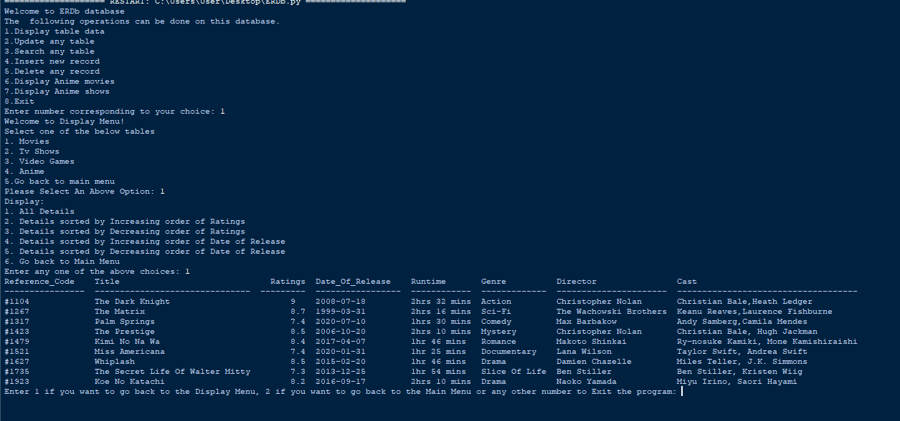

2) Displaying all records in the table Tv_Shows in the Decreasing Order of Ratings.

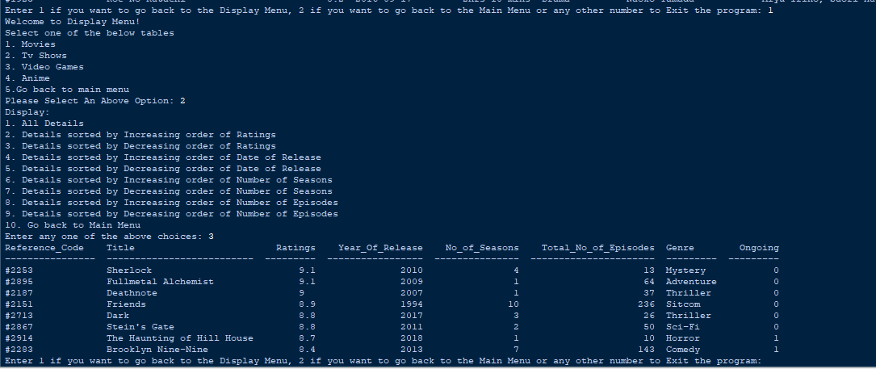

3) Displaying all details in table Video_games in the increasing order of date of release

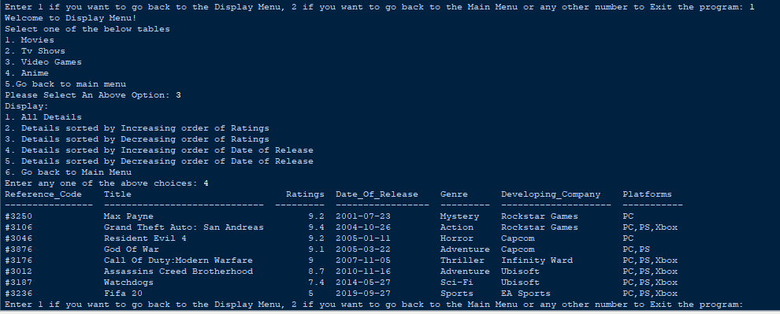

4) Displaying all records in Anime table sorted by increasing order of Number of episodes.

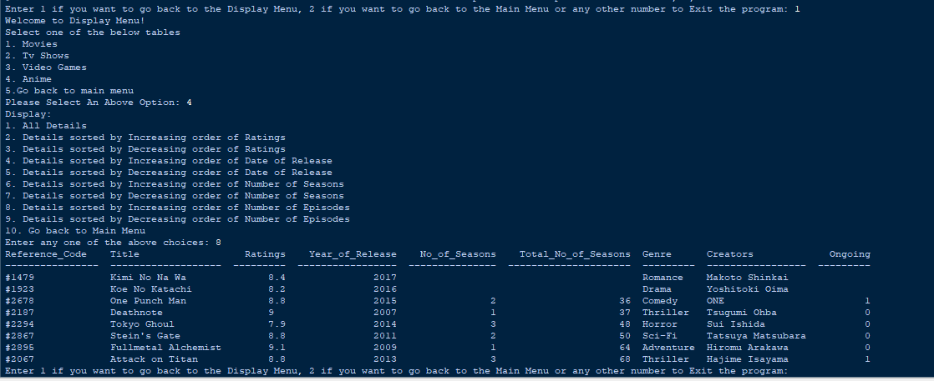

5) Updating the ratings of a movie in movies Table.

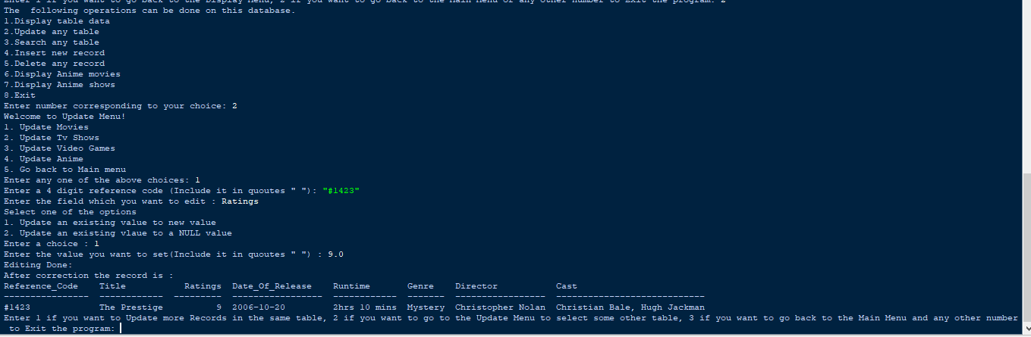

6)Updating the Genre of a Game

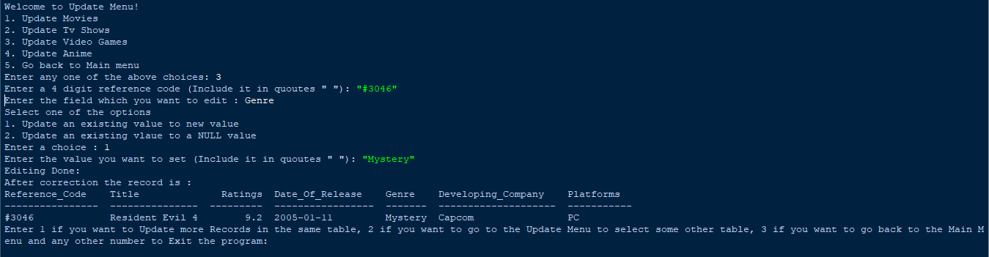

7) Searching for a movie by its Title

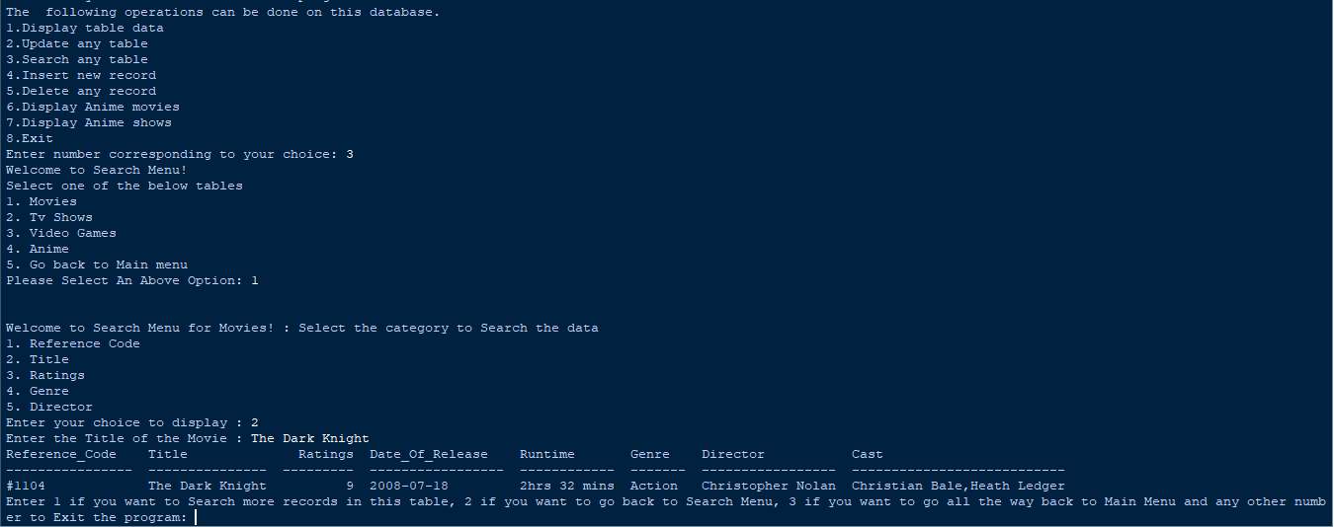

8)Searching for a tv show by ratings

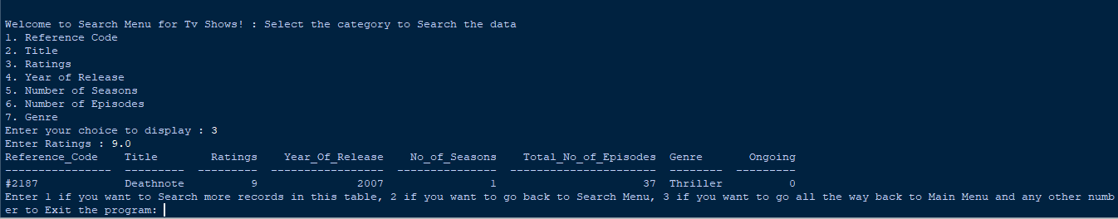

9)Searching for an anime Thriller

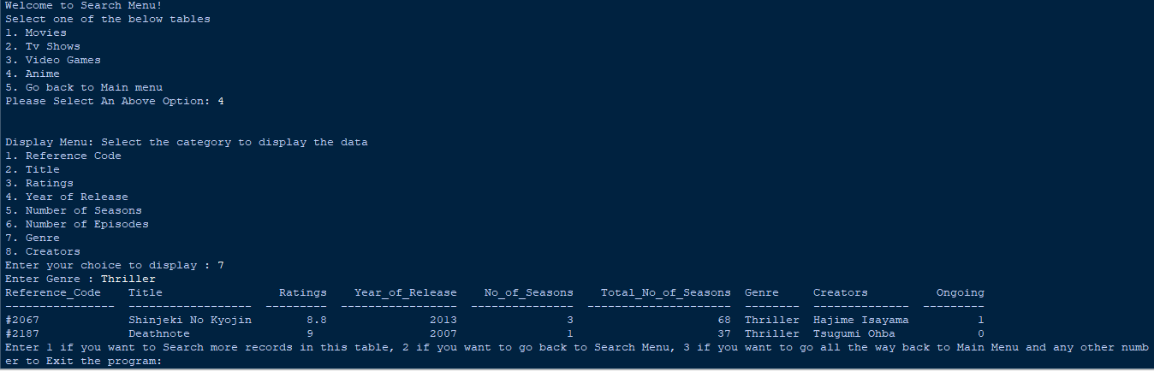

10) Inserting a movie to the movie Table

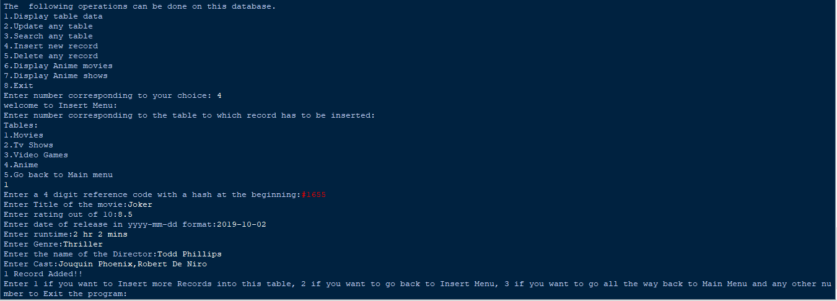

To Verify if Record is added,

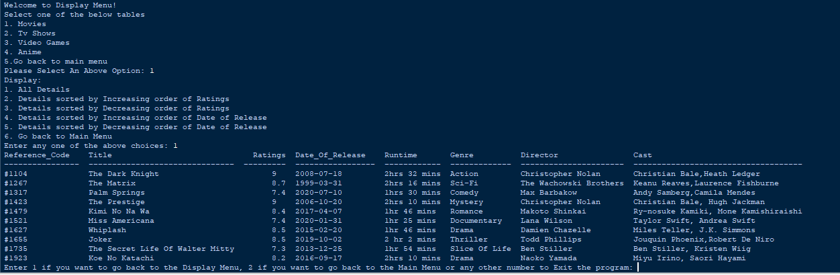

11)Delete a Game from the Records

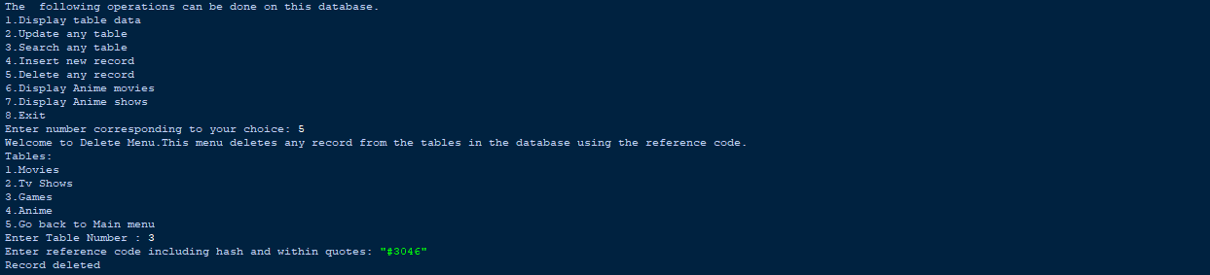

To check if it has been deleted,

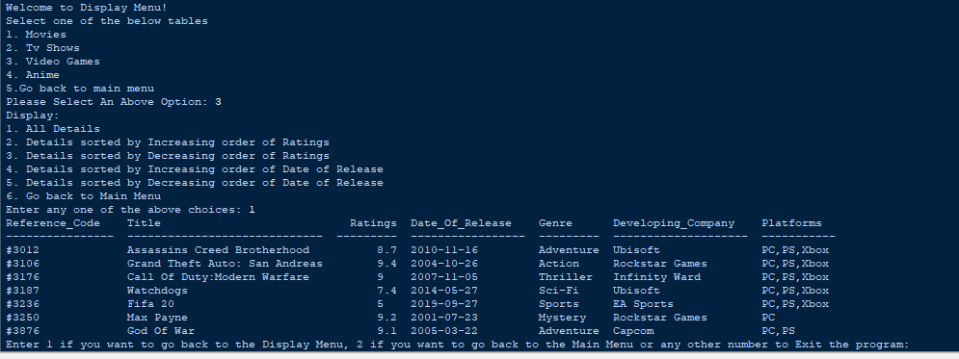

And indeed it has been deleted!

12) To Display Anime movies

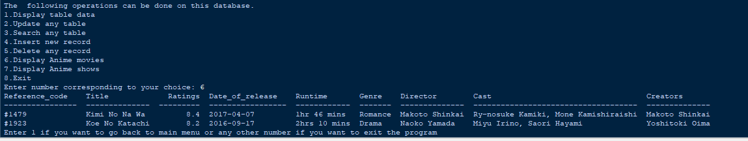

13) To display Anime shows

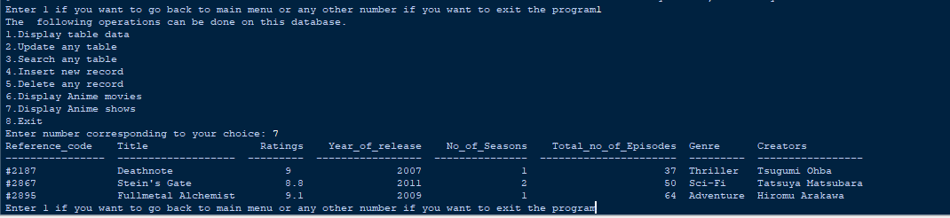

**References**

In order to work on this project titled – ***ENTERTAINMENT RATING MANAGEMENT SYSTEM,*** the following books, literature and links are referred by me during the various phases of development of the project:

1. <http://www.mysql.org/>
2. <http://www.python.org/>
3. <http://www.imdb.com/>
4. On-line Help of Python ®
5. Computer Science for Class XII

-by Sumita Arora

1. Various Websites of Discussion Forum and software development activities.

Other than the above-mentioned books, the suggestions and supervision of my teacher and my classmates also helped me to develop this software project.